**Debugging Render Processes using Chrome Devtools**

You can set breakpoints in a few different ways. First way is using a “debugger;” statement in the code. Open up your code and anywhere in the javascript code you can add the statement “debugger;”. Another way is setting breakpoints in devtools by clicking on the line number where you want to set the breakpoint. We will go through both of these below.

Note: To get breakpoints working, the dev tools needs to be open first. To open or close the devtools use cmd + option + I for mac and f12 or ctrl + shift + I for windows. Once the app has started, click on the dev tools window to get focus on it, and refresh the page using command + r or ctrl + r. Now it should hit the breakpoints and stop. Now you can do any debugging activities like stepping through, seeing values, setting watches, etc.

Open assets/js/catalog.js in your code editor. At line 5 add the statement “debugger;”



Now if you had electron-reload working, the app should automatically reload itself once you save the change and it should stop on the breakpoint if your devtools are open. If you don’t have eletron-reload then restart the app using npm run start. Make sure your devtools are open, if they aren’t then cmd + option + I will open them for mac and f12 or ctrl + shift + I for windows. Once they are open, click on the window to focus on it and press cmd + r or ctrl + r to refresh. Now you should hit the breakpoint.

To set a breakpoint in the dev tools open the sources tab, open the file you wish to set the breakpoint on (catalog.js in this case). If you don’t see the file you can search for it by pressing cmd + p or ctrl + p and typing in catalog.js. Once the file is open click on the line number on the line you wish to set the breakpoint, it will display a blue marker on it once it’s set. Then refresh the app using cmd+r or ctrl + r and it will stop on the breakpoint.



Errors**:**

Remove the debugger statement and add the following line “myVar++”

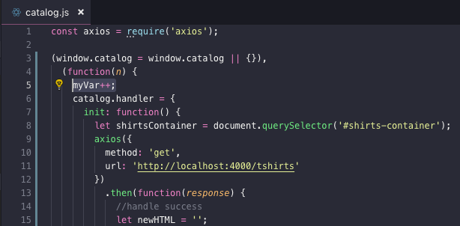

Now when you start your app if you go to the console tab in the developer tools you should see the error and some details about it.

You can also click on the following button to make the debugger pause on exceptions 

Now once you have the pause on exceptions selected and you refresh it will pause once it hits the error like so:



**Debugging Main Process using VSCode Debugger**

* Add a folder named .vscode
* Inside that folder add a file named launch.json
* Inside .vscode/launch.json add the following code:

{

"version": "0.2.0",

"configurations": [

{

"name": "Debug Main Process",

"type": "node",

"request": "launch",

"cwd": "${workspaceRoot}",

"runtimeExecutable": "${workspaceRoot}/node_modules/.bin/electron",

"windows": {

"runtimeExecutable": "${workspaceRoot}/node_modules/.bin/electron.cmd"

},

"args" : ["."],

"outputCapture": "std"

}

]

}

Open the debugger tab and open main.js and set a breakpoint by clicking just to the left of the line number like so:

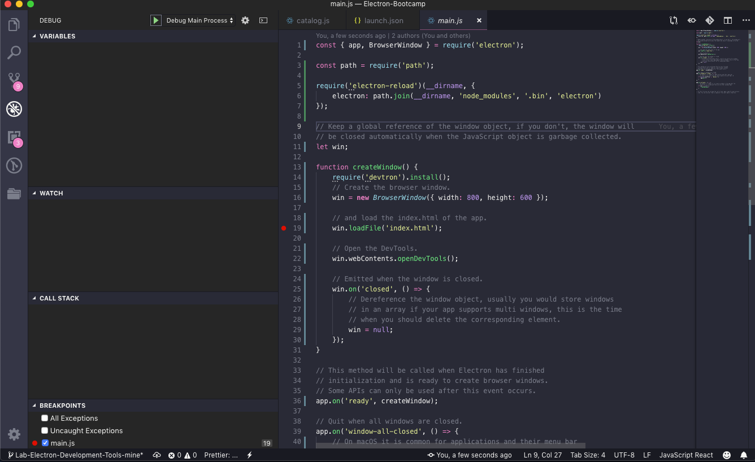

You can also use “debugger;” statements like so:

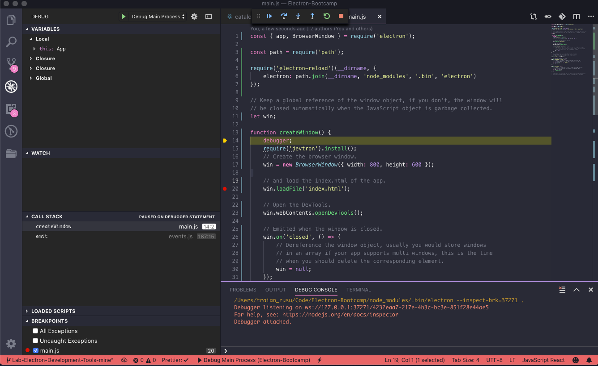

Then start debugging by pressing the green play button in the top left and the code will pause on your breakpoint.